Bridget Antwiwaa

Project 1

03/11/2022

Table of Descriptive Statistics

**All variables**  
================================================================  
Statistic N Mean St. Dev. Min Max   
----------------------------------------------------------------  
Gas Consumption 563 37.515 2.673 22.413 45.977   
Real Gas Price 563 1.774 0.502 0.988 3.346   
Real Dis Income 563 25,030.130 6,237.732 15,166.740 45,098.830  
Unemployment Rate 563 6.314 1.715 3.500 14.700   
One Year Treasury 563 6.060 3.299 0.620 15.320   
Ten Year Treasury 563 4.832 3.796 0.050 16.720   
Inflation 563 3.229 2.420 -1.500 11.600   
----------------------------------------------------------------

**Period 1**  
==========================================================================  
Statistic N Mean St. Dev. Min Max   
--------------------------------------------------------------------------  
Year 60 1,977.833 1.475 1,975 1,980   
Month 60 6.500 3.481 1 12   
Gasoline Consumption 60 214,402.500 13,287.150 181,641 244,041   
Real Price of Gas 60 0.796 0.235 0.586 1.271   
Disposable Personal Income 60 21,116.200 580.397 20,012 21,908   
Population 60 222,372.400 3,478.709 216,851 228,515   
Consumption Expenditures 60 34.426 3.922 29.132 42.351   
Inflation 60 7.585 1.887 5.100 11.600   
One Year Treasury 60 8.711 1.426 6.870 12.750   
Ten Year Treasury 60 8.338 2.581 4.890 15.820   
Unemployment Rate 60 6.798 0.810 5.600 8.300   
Per Capita Gas Consumption 60 40.509 2.658 35.105 45.977   
Real Price of Gasoline 60 1.774 0.315 1.507 2.443   
Real Per Capita Dis Income 60 16,489.750 453.235 15,627.470 17,108.070  
Jan-Dec 60 0.083 0.279 0 1   
--------------------------------------------------------------------------

**Period 2**  
==========================================================================  
Statistic N Mean St. Dev. Min Max   
--------------------------------------------------------------------------  
Year 60 2,003.167 1.475 2,001 2,006   
Month 60 6.500 3.481 1 12   
Gasoline Consumption 60 272,516.500 12,645.630 238,713 295,651   
Price of Gas 60 1.745 0.397 1.130 2.927   
Disposable Personal Income 60 35,593.630 954.311 33,954 37,591   
Population 60 291,064.500 3,915.130 284,380 297,734   
Consumption Expenditures 60 83.117 2.786 79.395 88.417   
Inflation 60 2.172 0.692 0.700 3.800   
One Year Treasury 60 4.420 0.459 3.330 5.390   
Ten Year Treasury 60 2.440 1.072 1.010 4.680   
Unemployment Rate 60 5.447 0.495 4.300 6.300   
Per Capita Gas Consumption 60 39.322 1.704 34.619 42.113   
Real Price of Gasoline 60 1.630 0.318 1.104 2.598   
Real Per Capita Dis Income 60 27,795.250 745.226 26,514.850 29,355.000  
--------------------------------------------------------------------------

**Period 3**  
==========================================================================  
Statistic N Mean St. Dev. Min Max   
--------------------------------------------------------------------------  
Year 60 2,018.833 1.475 2,016 2,021   
Month 60 6.500 3.481 1 12   
Gasoline Consumption 60 273,017.900 23,478.900 175,973 304,844   
Price of Gas 60 2.560 0.340 1.876 3.385   
Disposable Personal Income 60 45,415.680 2,715.579 42,147 57,752   
Population 60 328,189.200 2,307.159 324,052 331,716   
Consumption Expenditures 60 109.760 3.115 104.826 117.450   
Inflation 60 1.967 0.936 0.400 5.100   
One Year Treasury 60 1.971 0.755 0.620 3.150   
Ten Year Treasury 60 1.233 0.934 0.050 2.700   
Unemployment Rate 60 5.097 2.281 3.500 14.700   
Per Capita Gas Consumption 60 34.950 3.105 22.413 39.010   
Real Price of Gasoline 60 1.819 0.219 1.329 2.251   
Real Per Capita Dis Income 60 35,465.330 2,120.609 32,912.800 45,098.830  
Jan - Dec 60 0.083 0.279 0 1   
--------------------------------------------------------------------------

Graphs

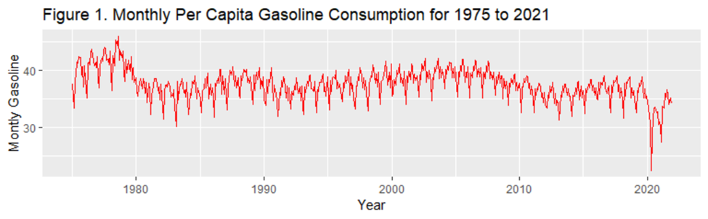

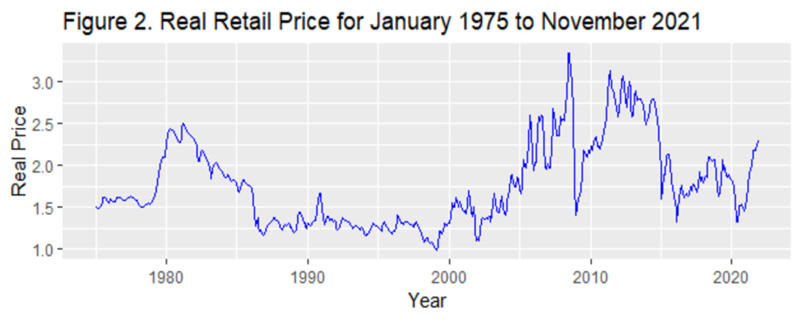

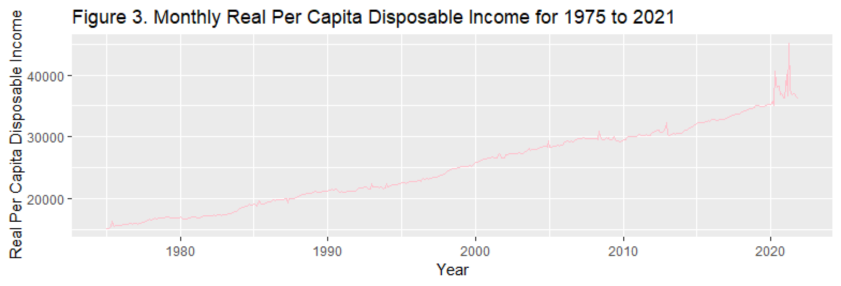

Figure 3: Real Retail Gasoline Price for three periods from Nov 1975 through Nov 1980, Mar 2001 through Mar 2006, and Feb 2015 through Feb 2020

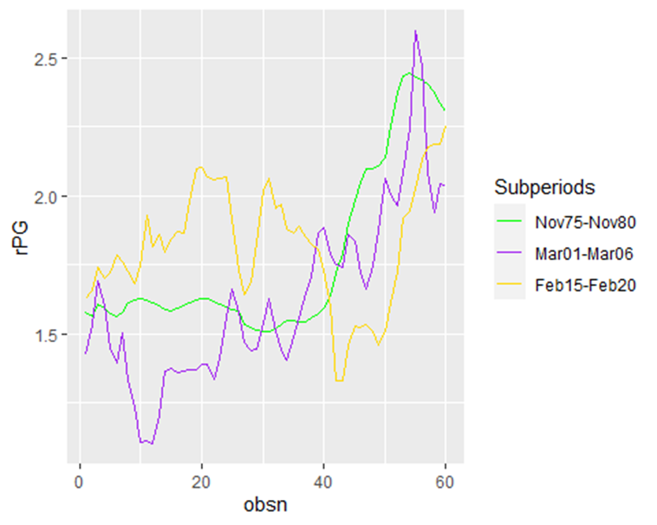

Regressions

**Table 1. OLS Regression Results – Double-log Basic Model**  
=======================================================================  
 Dependent variable:   
 -----------------------------------------  
 log(PCGC)   
 1975-1980 2001-2006 2016-2021  
------------------------------------------------------------------------  
 log(P) -0.309*** -0.042*** 0.367***   
 (0.023) (0.013) (0.057)   
   
 log(Y) 0.524*** 0.554*** -0.856***   
 (0.136) (0.091) (0.123)   
   
 Jan -0.080*** -0.044*** -0.033   
 (0.016) (0.007) (0.032)   
   
 Feb -0.130*** -0.120*** -0.117***   
 (0.016) (0.007) (0.032)  
   
 Mar -0.019 -0.007 0.017  
 (0.016) (0.007) (0.032)   
   
 Apr -0.023 -0.025*** -0.075**   
 (0.016) (0.007) (0.032)   
   
 May 0.012 0.025*** -0.0004   
 (0.016) (0.007) (0.032)   
   
 Jun 0.019 -0.001 0.004   
 (0.016) (0.007) (0.032)   
   
 Jul 0.028* 0.040*** 0.031   
 (0.016) (0.007) (0.033)   
   
 Aug 0.040** 0.043*** 0.035   
 (0.016) (0.007) (0.032)   
   
 Sep -0.029* -0.039*** -0.044   
 (0.016) (0.007) (0.033)   
   
 Oct 0.0004 0.006 -0.011   
 (0.016) (0.007) (0.032)   
   
 Nov -0.048*** -0.033*** -0.035   
 (0.016) (0.007) (0.032) $β_{o}$  
   
 -1.200 -1.965** 12.315***   
 (1.312) (0.925) (1.293)   
   
 --------------------------------------------------------------------------  
 Observations 60 60 60   
 R2 0.881 0.955 0.791   
 Adjusted R2 0.847 0.942 0.732   
## Residual Std. Error (df = 46) 0.026 0.011 0.050 (df = 46)   
## F Statistic (df = 13; 46) 26.143*** 74.913*** 13.419*** (df = 13; 46)  
## =========================================================================  
## Note: *p<0.1; **p<0.05; ***p<0.01

**Table 2. OLS Regression Result-Basic Model**  
==========================================================  
 Dependent variable:   
 ----------------------------  
 PCGC   
 (1) (2)   
 ----------------------------------------------------------  
 P -5.809*** -0.178   
 (0.968) (1.045)   
   
 Y 0.001* 0.0004   
 (0.001) (0.0004) $β_{o}$  
   
 29.209*** 27.986**   
 (10.464) (11.181)   
   
 ----------------------------------------------------------  
 Observations 60 60   
 R2 0.391 0.026   
 Adjusted R2 0.369 -0.009   
 Residual Std. Error (df = 57) 2.111 1.711   
 F Statistic (df = 2; 57) 18.278*** 0.747   
 ==========================================================  
 Note: *p<0.1; **p<0.05; ***p<0.01

**Table 4. OLS Regression Results – Macroeconomic Variables**

==========================================================

Dependent variable:

----------------------------

log(PCGC)

(1975-1980) (2016-2021)

----------------------------------------------------------

log(P) -0.200*** -0.434***

(0.065) (0.128)

log(Y) 0.420 -0.027

(0.333) (0.149)

log(Inflation) -0.070 0.162***

(0.050) (0.032)

log(1-yr BR) -0.014

(0.063)

log(10-yr BR) 0.030***

(0.009)

log(UE) -0.094 -0.144***

(0.064) (0.041)

Jan -0.081*** -0.043*

(0.016) (0.022)

Feb -0.131*** -0.116***

(0.016) (0.022)

Mar -0.020 0.011

(0.016) (0.023)

Apr -0.024 -0.009

(0.016) (0.025)

May 0.010 0.081***

(0.016) (0.026)

Jun 0.015 0.077***

(0.017) (0.025)

Jul 0.025 0.096***

(0.016) (0.025)

Aug 0.037** 0.093***

(0.016) (0.024)

Sep -0.032* 0.017

(0.016) (0.024)

Oct -0.001 0.043*

(0.016) (0.024)

Nov -0.047*** -0.001

(0.016) (0.023)

Constant 0.101 4.208***

(3.272) (1.512)

----------------------------------------------------------

Observations 60 60

R2 0.891 0.904

Adjusted R2 0.850 0.869

Residual Std. Error (df = 43) 0.026 0.035

F Statistic (df = 16; 43) 21.859*** 25.434***

==========================================================

Note: *p<0.1; **p<0.05; ***p<0.01

Appendix

Importing my data

data1= read.csv(choose.files(), header = T)

calling my data

GC = data1$Gasoline.Consumption  
PG = data1$Price.of.Gas  
rDPI = data1$Disposable.Personal.Income  
Pop= data1$population  
PCE=data1$Consumption.Expenditures  
Infla= data1$Inflation  
one.T= data1$One.year.treasury  
ten.T= data1$ten.year.treasury  
UR = data1$Unemployment.rate  
Year = data1$Year  
month = data1$Month  
date = data1$Date

per capital gasoline consuption variable (PCGC)

data1$PCGC= (GC*42)/(Pop)

real retail price of gasoline (rPG)

data2=subset(data1, Year == "2000")  
a=mean(data2[,8])  
PCE.deflator = PCE/a  
data1$rPG = PG/PCE.deflator

real per capital disposable income(rCPI)

d2=subset(data1, Year == "2012")  
b=mean(d2[,8])  
PCE12.deflator = PCE/b  
data1$rCPI = (PCE12.deflator/PCE.deflator) *rDPI

create the 12 dummy variables

data1$Jan = ifelse(month==1,1,0)  
data1$Feb =ifelse(month==2,1,0)  
data1$Mar= ifelse(month==3,1,0)  
data1$Apr= ifelse(month==4,1,0)  
data1$May= ifelse(month==5,1,0)  
data1$Jun= ifelse(month==6,1,0)  
data1$Jul= ifelse(month==7,1,0)  
data1$Aug= ifelse(month==8,1,0)  
data1$Sep= ifelse(month==9,1,0)  
data1$Oct= ifelse(month==10,1,0)  
data1$Nov= ifelse(month==11,1,0)  
data1$Dec= ifelse(month==12,1,0)

Descriptive statistics for all variables

vars = data1[,c("PCGC", "rPG","rCPI","Unemployment.rate", "One.year.treasury",   
 "ten.year.treasury", "Inflation")]  
stargazer::stargazer(vars, type = "text")

Descriptive statistics of 3 specific time periods

date = as.Date(date)  
Time.d1 = subset(data1, date>="1975-11-01" & date<="1980-11-01")  
Time.d2 = subset(data1, date>="2001-03-01" & date<="2006-03-01")  
Time.d3 = subset(data1, date>="2016-11-01" & date<="2021-11-01")  
stargazer::stargazer(Time.d1, type = "text")

stargazer::stargazer(Time.d2, type = "text")

stargazer::stargazer(Time.d3, type = "text")

Time series graph of the main variables

PCGC graph

library(ggplot2)  
ggplot()+  
 geom_line(data = data1, mapping = aes(x=date,y=PCGC), col = "red")+xlab("Year")+ylab("Montly Gasoline")+labs(title = "Figure 1. Monthly Per Capita Gasoline Consumption for 1975 to 2021")

rPG graph

ggplot()+  
 geom_line(data = data1, mapping = aes(x=date,y=rPG), col = "blue")+xlab("Year")+ylab("Real Price")+labs(title = "Figure 2. Real Retail Price for January 1975 to November 2021")

rCPI graph

ggplot()+  
 geom_line(data = data1, mapping = aes(x=date,y=rCPI), col = "pink")+xlab("Year")+ylab(" Real Per Capita Disposable Income")+labs(title = "Figure 3. Monthly Real Per Capita Disposable Income for 1975 to 2021")

Time series graph of the main variables for all the time period

Time.d1$obsn = 1:nrow(Time.d1)  
Time.d2$obsn = 1:nrow(Time.d2)  
Time.d3$obsn = 1:nrow(Time.d3)  
  
windows(width = 12, height = 10)  
ggplot(NULL, aes(obsn, rPG))+  
 geom_line(data =Time.d1, aes(col = "green"))+  
 geom_line(data =Time.d2, aes(col = "purple"))+  
 geom_line(data =Time.d3, aes(col = "gold"))+  
 scale_color_identity(name = "Subperiods", breaks = c("green", "purple", "gold"), labels =c("Nov75-Nov80", "Mar01-Mar06", "Feb15-Feb20"), guide = "legend")

D. Estimates of Table 1 Models

reg1=lm(log(PCGC)~log(rPG)+log(rCPI)+Jan+Feb+Mar+Apr+May+Jun+Jul+Aug +Sep+Oct+Nov,data = Time.d1)  
reg2=lm(log(PCGC)~log(rPG)+log(rCPI)+Jan+Feb+Mar+Apr+May+Jun+Jul+Aug +Sep+Oct+Nov,data = Time.d2)  
stargazer::stargazer(reg1,reg2, type = "text")

E. Estimate Table 2 model for linear Model

linear.reg1=lm(PCGC~rPG+rCPI,data = Time.d1)  
linear.reg2=lm(PCGC~rPG+rCPI,data = Time.d2)  
stargazer::stargazer(linear.reg1,linear.reg2,type = "text")

F. Estimate Table 4:

Infla.reg1=lm(log(PCGC)~log(rPG)+log(rCPI)+log(Inflation)+log(One.year.treasury)+log(Unemployment.rate)+Jan+Feb+Mar+Apr+May+Jun+Jul+Aug+Sep  
 +Oct+Nov,data = Time.d1)  
stargazer::stargazer(Infla.reg1, type = "text")

G. Estimate Elasticities Using Recent Data

Covid.reg1=lm(log(PCGC)~log(rPG)+log(rCPI)+Jan+Feb+Mar+Apr+May+Jun+Jul+Aug+Sep+Oct+Nov,data = Time.d3)  
  
Covid.reg2=lm(log(PCGC)~log(rPG)+log(rCPI)+log(Inflation)+log(ten.year.treasury)+log(Unemployment.rate)+Jan+Feb+Mar+Apr+May+Jun+Jul+Aug+Sep+Oct+Nov,data = Time.d3)  
  
stargazer::stargazer(Covid.reg1,Covid.reg2, type = "text")